1. Fundamentals

1.1 Introduction

1) Localization and positioning are used for estimation of the state of a connected device in a global frame of reference.

2) Monostatic sensing is a local process, and can thus rely on a tailored, highly specialized, and hardware friendly waveforms, without strict standardization constraints.

3) Bistatic sensing is similar to communication and localization (i.e., when the transmitter or receiver have an unknown position).

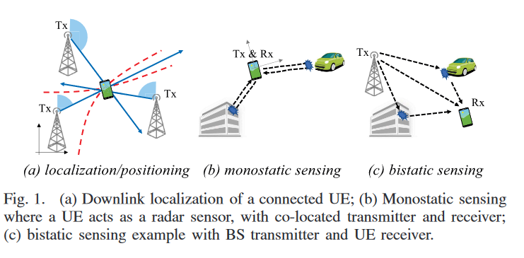

With radar systems and communication systems expected to **operate in similar frequency bands**, **there is a potential convergence**, both in terms of hardware and signals, **of sensing and communication systems**.

Integrated sensing and communication (ISAC) is expected to be the main features of 6G.

1.2 Models and Problem Definitions

1.2.1 Generic Observation Model

1.2.1.1 Channel Model

The channel between a transmitter with  Antennas and a receiver with  over frequency  and symbol  can be approximated by:



where  is the number of multipaths,  is the complex channel gain,  is the Rx array response as a function of angle of arrive (AoA)  in azimuth and elevation,  is the Tx array response as a function of angle of departure (AoD),  is the time of arrive (ToA),  is the Doppler shift, and  is the symbol duration.

1.2.1.1 Signal Model

The observation at the Rx is then of the form:



where  is the orthonormal analog Rx combiner with  using  RF chains,  is the -th transmitted signal over the -th subcarriers with  of which , and  is the circular symmetric complex Gaussian random noise. Here  and  denote the average transmit power and noise power spectral density, respectively.